Final Project Proposal
Nicholas Antonio
20 March 20, 2026
EN.525.665.81.SP26
Abstract.
Location sensing and geo-positioning are fundamental elements of machine perception. This area of investment is largely considered solved for the commercial sector due to the ubiquity of GPS and cellular triangulation. Periods in which systems cannot receive adequate external fixes are often supplemented by low-cost MEMs inertial measurements units (IMUs). However, these low cost IMUs suffer from significant drift over time and cannot be used to provide accurate positioning over a long period of time. My proposal is to investigate the use of a low cost IMU array in concert with a recursive neural network to reduce drift through sensor fusion.
Technical Challenge.
The technical challenge is to develop a neural network that can provide position estimations based on IMU sensor data. Some of the key tasks will be to properly normalize data and convert to a shared coordinate space, develop a model capable of making predictions on the normalized data, and training the model to provide accurate predictions.
Approach.
The first step is to collect a large amount of time-synchronized GPS and IMU data using a sensor array. To further enhance the exploration of sensor arrays, multiple different MEMs products could be used to reduce the chance that similar environments produce similar noise. Luckily, a data collection platform has been “installed” in my personal vehicle for the last three months and has collected approximately 7Gb of useful training data. This data contains the raw output of six, 9 degree of freedom IMU sensors and a high accuracy GPS.
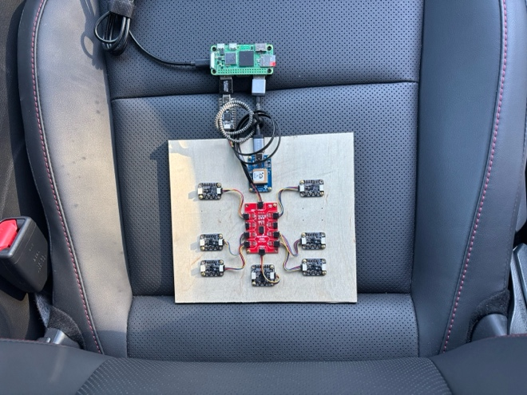
Figure 1. I live in constant fear of being pulled over with this in my car.
The model structure will require additional investigation, but there are some assumptions I can make in this approach. The model will likely need to be a recursive neural network, this will allow the model to run on data in real time and allow for information such as velocity to be passed back into the model as in internal output. Part of the goal is to encode sensor level tendencies for noise and averaging into the weights of the model in order to produce a more accurate output. A one hot encoded input may be a good choice for achieving this since it breaks each sensor into a discrete part of the input and therefore provides them with weights linked to that input data directly. Additional attributes may also get encoded into the model, such as the orientation of the sensors relative to the vehicle, or certain driving dynamics. Once a model is properly trained, the sensor array can be moved to a different platform to compare the performance on a different installation environment.

